Aonghus O’Laoire

AAA Vet Care Ltd

16 Maple Lawns,

Oldtown Demesne,

Naas

Co. Kildare.

4th May, 2021

**Android Cattle Scanning Application**

**Overview**

AAA Vet Care require the development of an Android mobile application for Vets in the field that will allow them to record TB from cattle information while attending visits to farms. The features and processes required within this mobile application are as follows

App Operations

1. The App will be designed to allow the user to utilise the physical keys on the device as they operate with gloves in dirty environments and touchscreen interactions are not always possible. The touchscreen would need to be disabled or avoid activation on the tb testing screen in case rain, hailstone triggers an action.
2. The screens will need to be black & white to allow for best visibility in bright light
3. Field focus will be important to ensure that the user needs to click the minimum amount of times to execute an action

**Start Process**

1. The first step in the process is where a file in generated from a dept of agriculture website (XML Type) which is downloaded onto the user’s computer
2. We will configure a location where this file can be downloaded which will convert the file into a useable format that can be synched directly to the Android device without needed intervention.
3. The file will populate the Android device with a list of cattle that need to be examined by the vet
4. The Vet will attend site to perform a test in the following manner,

**Blood Test Criteria**

1. When the vet initiates a test for the first time they should be prompted in relation to performance of a ‘Blood Test’
2. A blood test can be triggered in a number of ways
   1. The download file flag ‘testinc-criteria’ could indicate a blood test is required. In this situation the vet must test ‘all animals’ in the herd.

There is no flag ‘testinc-criteria’ in the sample XML file. Please advise which field refers this flag in the XML file

We don’t have to look for this flag or do anything with it.

OK

* 1. If an individual animal has not got a ‘PI-NEG’ status then this should also prompt the vet to perform a blood test.

We will consider the field <bvd-status> has not got ‘PI-NEG’ value for individual animal to identify a blood test is required or not.

Please refer to BVD document sent over on how to manage this. Ignore items 7 & 8 in this document

We will follow below rules from BVD document

|  |
| --- |
| if one of these codes listed below is entered as the animal's BVD status please enter pop-up with associated warning.  If PINEG etc then ignore  1. BVDNOSMP -BVD NOSMP Take blood sample (Y/N)?  2. PIPos - PI Pos Take blood sample (Y/N)?  3. PIInc - PI Inc Take blood sample (Y/N)?  4. BVDPos - BVD Pos Take blood sample (Y/N)?  5. BVDInc - BVD Inc Take blood sample (Y/N)?  6. BVDSus - BVD Sus Take blood sample (Y/N)? |

* 1. The Vet could decide himself that we wants to perform a blood test
  2. He must then be promoted to input the Age & Sex criteria for performing the test

The following are the steps that a Vet will move through to select animals for blood testing. This is somewhat odd and animals could be selected in multiple categories so it will collate the list of animals across all categories selected.

1. Do you wish to blood sample Y or N (If Y go to 2 below)
2. All animals Y/N If N go to 3.
3. Cows Y/N - All or Age (>X<Y)
4. Female Y/N - All or Age (>X<Y)
5. Bull Y/N - All or Age (>X<Y)
6. Male Y/N - All or Age (>X<Y)
   1. When he comes to an animal while performing the test he will then be prompted at the end of the TB details to perform the test and then enter in the Blood Bottle Number
   2. The blood bottles will be sequenced so if the first is 1001 then the next will be 1002, etc

We will use the field “tube-code” to record Blood bottle number.

No. The blood sampling is not part of the xml export. We will be exporting a csv file with the animal tag no, DOB, animal class and Bottle number for the vet to use elsewhere, send to 3rd party lad.

OK. We will add a field Blood bottle number to record it. Also we will provide option to export csv file with the animal tag no, DOB, animal class and Bottle number

Separate Blood Testing (Lets discuss this as a separate process as it involves a separate file)

In certain situations the vet may download a herd profile and blood test specific animals as described above but not along with the TB test. We are providing a sample of a herd profile downloaded from AHCS which isn’t due to be TB tested but the farmer may wish to blood sample animals from this list.

You can also see INDINEG8 rather than PI-NEG. Still it would be simpler to prompt the vet once the animal doesn’t have a PI-NEG status. For example DO YOU WISH TO BLOOD SAMPLE COW NO. 123456 WHO HAS AN UNKNOWN BVD STATUS? Y or N.

Blood Test Criteria will be completed in Phase 2

**Performing a Test (Day 1)**

1. When the vet starts to perform the actual test they will be performing a Day1 or a follow up Day2 test which they will select on the App. If Day1 is selected it will show all farmers available for Day1 test, selecting Day2 will show those farmers due for follow up.

The Farmer details is not available in the provided sample XML file. Please advise where it is coming from.

I sent you a separate email on this with explanation. Lets refer to this as the Farmer Test Download File.

Based on the email, we will consider the herd-no and address-line-1 as former details.

1. The vet will now select the Farmer which will display the Test Entry screen. The date field should default to today but be editable. The vet can edit the PVP field value and must enter in the Tuberculin 1 & 2 field values. They then hit continue.

We can see “interp-level-pvp” field in the download file. Is this field is referred here as PVP field? Please confirm

No, the PVP field called <actual-tester>

OK

The date field, PVP field, Tuberculin 1 & 2 fields will be one-time entry. It does not require for each animal.

Correct

1. They will now be presented with a screen to enter in a Batch Name/Number and hit continue.
2. A field called ‘Interpretation’ is also visible telling the vet the severity with which the values they enter will be measured against to determine if the animal is ‘positive or negative’. How these measurements work are covered in a different section.

The ‘Interpretation’ field will have below values

* + Standard
  + Severe

Based on this selection the formula will apply. If the field “interp-level” has STA then Standard measurement will be applied by default.

Correct

1. The App will now present he Vet with the list of animals for testing
2. The vet must first physically check the animal for identification. This is done by checking the animal TAG number.
3. The vet will need a method to reveal the TAG Field in order to enter the animal TAG number to search and locate the animal.
4. Once the animal is located, this will open up the Test Readings Entry Screen displaying the core animal information for the vet to enter in the required A & B values
5. Once these values are entered, the screen clears and presents the vet with the search field again to search for the next animal TAG number

Day 1 test will be completed in Phase 2

**Performing a Test (Day 2)**

1. When the vet selects Day2 test they will be presented with the list of farmers applicable
2. Selecting the farmer will display the values entered in on Day one of the core screen
3. The vet can now click to access the animal list of this Day2 test
4. The vet can now click to search for the first animal for Day2 test

The order of animal listed based on the Day1 test. The order is recorded in the below fields

testing-order-tB – The sequence of animal tested in Day 1 for TB test

testing-order-bR – The sequence of animal tested in Day 1 for Blood test

Correct, but ignore reference as not applicable for Blood testing

OK. We hope that the sequence is not applicable for Blood test. So we will ignore testing-order-bR sequence. Please confirm

1. Once located it opens the Day2 record with focus on the Day2 A&B fields for the Vet to Enter
2. This will display the ‘differential values’ in the diff fields based on Day1 – Day2
3. These values are used to determine if the animal tests ‘positive or negative’ comparing them to the standard/severe ‘interpretation matrix’ depending on the test instruction.
4. If the values determine that the animal is ‘positive/reactor’ a message will flash up for the vet with a field for them to enter in a ‘Reactor TAG Number’. If an animal if identified as a reactor a TAG must be entered

The Reactor TAG number will be recorded in the export file “reactor-tag”

Correct

1. If during a test the vet identifies 2 animals as reactors, a message will appear to the vet telling them that the test is now classified as ‘severe’ and giving them the option to switch to severe measurements.
2. This will now treat all further animal test results against the severe matrix but will also reapply the severe matrix values against all animals already tested.
3. Once all animals have been tested the test is complete and the vet can access the test reports to view the results. These reports are covered in a later section
4. Once the visit has been completed, the data file for the farmers test will be exported to the cloud where it will be auto converted back into an XML format for upload back to the department portal.

The output XML file will be exported from the Device to the user’s computer using WIFI.

We hope this report file will be exported to the cloud manually by the user and it will be auto converted into XML format. This XML file will be uploaded back to department portal manually by the user. Please confirm

This process is covered in a separate email explaining download & upload processes

We will follow below download & upload process which one is covered in a separate mail

|  |
| --- |
| Download   1. Aonghus will register each Vet on the TK Portal    1. This will provide the vet with an page where they can upload a file they download from the department portal 2. Vet will download file from department portal 3. Vet will login to TK and upload file or files 4. Portal will convert file into format for use by handheld 5. Handheld will sync files down from Tk for test processing   Test   1. Vet will visit farm and perform Day 1 or Day 2 tests 2. When Day 2 test is completed file can be uploaded to portal automatically 3. Portal will now transform file into XML format for upload to department site   Upload   1. Vet will login to portal and download the completed test file 2. Vet will login to department site and upload completed test file |

Day 2 test will be completed in Phase 2

The download and upload process will be completed in Phase 3

**Testing Scenarios (No TAG)**

1. In some cases while testing the vet will not be able to identify the animal because no TAG will be present or the tag will be ILLEGIBLE.
2. In this case we need to provide the vet with an option to open a different form to enter in a manual TAG number preceded by TTxxxxx and capture other relevant information. The vet must enter in an approximate DOB using (MM/YYYY) but this will write this to the export file as 01/MM/YYYY. We would also need to enter sex,breed and class also.

We will provide add option for animal to add new animals.

This is explained in more detail in a separate email

We will follow below for TT process which one is covered in a separate mail

|  |
| --- |
| cid:image003.jpg@01D7732C.7CD220E0    This is an example of a new animal being added to the list where the TT number is entered and tag type then shows TT    A second scenario is where the VET chooses an existing animal number that he feels is the match and he also enters in a TTnumber into the TTnumber field but this just adds TT to the tag type    See below    cid:image005.jpg@01D7732C.7CD220E0 |

1. Depending on the Animal Type and Age, this will identify the animal and write this to the export file also

Female < 6 months = calf CLF

Male < 6 months = calf CLF

Female > 6 months = Maiden Heifer MH

Male > 6 months = Steer S

Based on the age we can classified the animal. We can write this value in the field “animal-class-result”. We can see some additional list of values for the field “animal-class-result” as below in the import and export file.

MH - Female > 6 months

S - Male > 6 months

CLF - < 6 months for Male or Female

C -

CO -

ST -

CA -

We need all available formula to write this value when a new animal record is created.

Testing Scenarios (No TAG) will be completed in Phase 3

**Testing Scenarios (Suspected TAG No)**

1. In some cases the vet may suspect that an animal is TAG No (XXXX). They will enter this value to locate the animal on the App and in the Notes Field enter in a team TAG Number TTxxxxxx. These numbers are taken from Brass TAGS carried by each VET.

We will provide “Notes” fields in the animal core details to enter team TAG number.

Correct, this will not fill in any XML fiels but the Tag Type will show TT as above

OK

Testing Scenarios (Suspected TAG No) will be completed in Phase 3

**Measuring Standard & Severe Interpretations**

1. When values are being entered in Day2 of a test the animal is being checked to see if they are a reactor or not. The differential values between Day1 and Day2 (A-B) values are compared against two sets of matrix, Standard & Severe and the matrix used this depends on the indicator within the test file. It can also change to severe interpretation if two animals test positive as reactors or if the vet decides to change to severe interpretation himself.

If the field <interp-level> value is SER then Severe matrix calculation will be applied.

Correct, can you confirm that its SEV

Yes. it is SEV

1. The possible results for a reading are Positive (+), Negative (-) and Inconclusive (0) and these values are written to the export file into the <pvp> tag. <pvp-result>-</pvp-result> = negative
2. If the Vet accepts the measurement change to severe then a final report will show each animal as having changed like below
   1. STD (-) Negative to SEV (0) Inconclusive
   2. STD (0) Inconclusive to SEV (+) Positive

1. The Vet will need to be able to switch to the Severe interpretation manually and back again to standard if needed.

We will provide option to change the interpretation mode standard to Severe and Severe to Standard

Correct

1. A Vet should also be able to start a test in Severe interpretation mode

Measuring Standard & Severe Interpretations will be completed in Phase 2

**Standard Interpretation Formula**

* If the Difference between Day 2 minus Day 1 (B) Readings is <= 2 then the reading is always Negative
* If the difference between Day 2 minus Day 1 (B) Readings – (A) Readings is <= 0 then the reading is Negative (-)
* If the difference between Day 2 minus Day 1 (B) Readings – (A) Readings is > 0 and <= 4 then the reading is Inconclusive (0)
* If the difference between Day 2 minus Day 1 (B) Readings – (A) Readings is > 4 then the reading is Positive/Reactor (+)

Severe Interpretation Formula

* If the Difference between Day 2 minus Day 1 (B) Readings is <= 2 then the reading is always Negative (-)
* If the difference between Day 2 minus Day 1 (B) Readings – (A) Readings is < (-2) then the reading is Negative (-)
* If the difference between Day 2 minus Day 1 (B) Readings – (A) Readings is >= (-2) <= (0) then the reading is Inconclusive (0) (IF DIFF-B MINUS DIFF-A is ≥ -2 ≤ 0 =INCONCLUSIVE)
* If the difference between Day 2 minus Day 1 (B) Readings – (A) Readings is > 0 then the reading is Positive/Reactor (+)

In the below screenshot, we assume that 72Hr will be static value and it will not change dynamically.

On the below screen based on a 2nd day test, the vet will manually enter in values into the two 72hr fields which will display the differences in the Diff fields.

OK

Standard Interpretation Formula and Severe Interpretation Formula will be completed in Phase 2

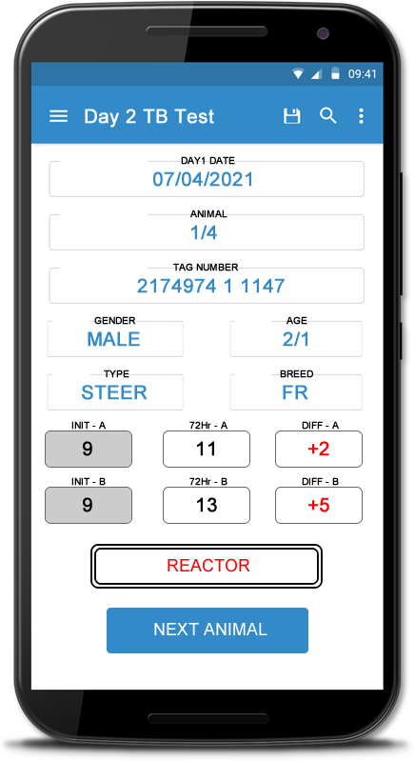

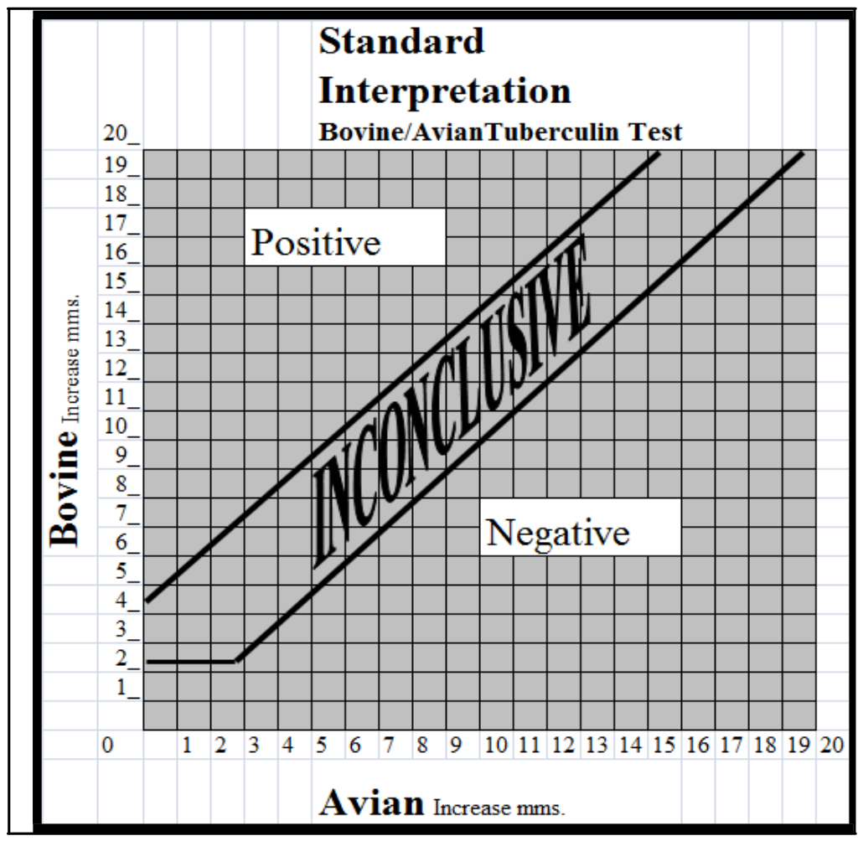

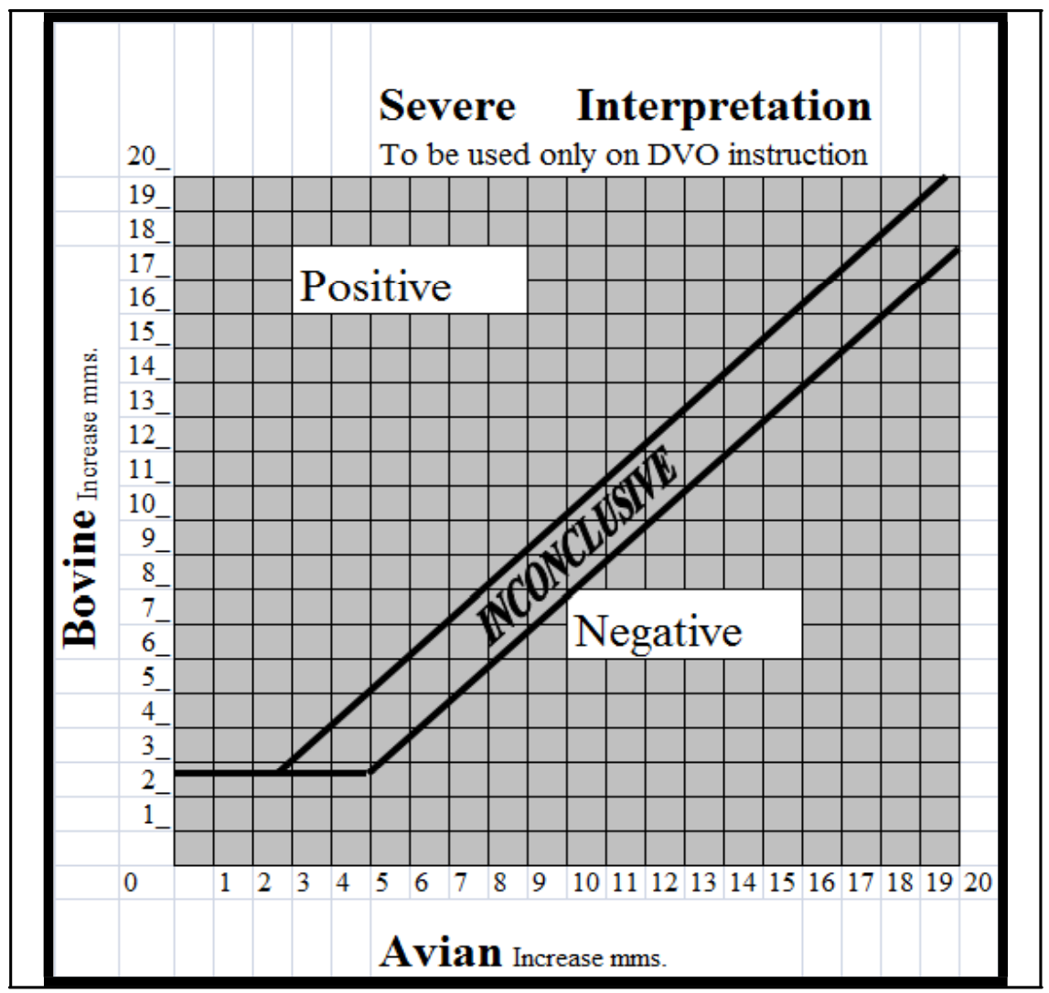

**Reactor Override Options**

1. When the vet is completing Day2 readings, even if the readings do not identify the animal as a reactor, the Vet can choose from some override options. These are as follows:-
   1. Circumscribed = Does not flag the animal as a reactor (C)
   2. Diffuse Oedema = Sets this animal as a Reactor (D0)
   3. Extensive Oedema = Sets this animal as a Reactor (E0)

We will use the field “AReaction” and “BReaction” to record these value

Correct

The Reactor Override Options will be completed in Phase 2

**Other Values written to Export File**

1. Clinical Remarks for an animal, CO=Cough, SN=Snoring, ST=Skin TB, EM=Emaciation, GL=Enlarged Lymph, MA=Mastitis

We can see “clinical-remark-code” field in the export file

Ok

1. Movement, you can enter this on the App but it does not come out as part of the XML file. Sold, Slaughtered, Dead, Purchased, Born-in

This field will be maintained in the device. We will add “Movement” field for animal.

Ok

1. Animal Passport, Codes recorded are NC=No Card, WC=Wrong Card, FC=Full Card, OK=Have Card

We can see “passport-code” in the export file

Ok

1. TB tests are done in Batches, A,B,C and a Location, Ballyragget

We can use “testing-group“ for batches and “testing-group-location” field for location

Ok

1. Day2, If the Vet enters value for Day 2 that are lower than Day 1 we should record the actual value entered but the difference should always calculate as 0, zero YES. 3 - 5 = -2 but the increase is 0

In the sample App page the Vet enters in the values for 72hr fields and the Diff fields display the Increase Value. Diff should be renamed Increase and there cannot be an increase of -1, minimum increase is zero even if its below zero

We will rename Diff as Increase and follow above rule

1. If the test is marked as completed we need to warn the Vet of any animals that have incomplete test data recorded for either Day 1 or Day 2. This should warn the Vet on both days.
2. The only reason values should not be entered into a test on day 1 but not day 2 is if the Vet records 'Clinical Remarks' instead. If you enter in readings for an animal on Day 1 you must enter them for Day 2 also, unless you sue clinical remarks.

The Day 2 entry can be skipped if Clinical Remarks is entered.

Yes

1. The date of this test should default to the current date but allow manual override. The actual test date field on the upload file is the day 2 date. <actual-tb-test-date>17/04/2021</actual-tb-test-date>
2. The sequence of the animals tested on day 1 needs to be recorded on the uploaded xml file.

We will use “testing-order-tB” field for TB test and “testing-order-bR” field for Blood test to record the sequence of the animals tested on day 1

Correct but not applicable for Blood tests as mentioned

OK. The Export File process will be completed in Phase 3

**Warnings - Checks**

These are the potential warnings that should appear prior to completion/upload of the test.

1. AHCS requires clinical remarks for all tested animals that have no day 2 readings.
   1. Must be rectified before upload
2. TB test date due in the future.
   1. Cannot upload a file on a future date
3. 3 untested animals.
   1. Just a notice, can still upload
4. 5 Invalid tags (I'll do further research)
   1. Just a notice, can still upload

How can we identify a tag is invalid? Please advise

I will explain this separately in a con call.

1. 6 animals with approximate D.O.B
   1. Just a notice, can still upload
2. TB positive animal with no reactor tag
   1. Cannot upload, must put in a recator tag
3. Animal 0234 gender has been changed
   1. Just a notice, can still upload
4. 6 animals added to TB test (This should be the same as animals with approximate D.O.B)
   1. Just a notice, can still upload

We will provide warnings to the user as stated above

If PI-NEG status then there is no need to prompt vet to blood sample an animal for BVD. However if not PI-NEG then WOULD YOU LIKE TO BLOOD SAMPLE 0234 TO CHECK IT'S BVD STATUS? If yes, then private blood sample. DISCUSSED ABOVE

1. Blood sampling as we discussed...
   1. Blood bottle 1 = Dept requests animals to be blood tested based on specific age/sex criteria but the xml file will indicate this either on an individual animal basis or a total herd instruction. Currently this is not happening as Brucellosis has been eradicated so we won't worry about it. However the vet may decide to take bloods on the day of the test for private use and he/she would blood sample them based on age/sex criteria.

We can see blood test is required or not for an individual animal based on the field bvd-status. But there is no indication for total herd. Please advise.

AS long as we are recording the data for the blood bottle as mentioned above we can ignore any other reference

OK

Animal Selection Process Required for Testing

1. All animals Y/N - All or go to 7.
2. Cows Y/N - All or Age (>X<Y)
3. Female Y/N - All or Age (>X<Y)
4. Bull Y/N - All or Age (>X<Y)
5. Male Y/N - All or Age (>X<Y)

This is the current selection process which selects based on class and/or sex and/or age.

1. If the vet wants to select a random few cattle during the test for disease surveillance purposes they would just select NONE and then just manually put in a bottle number for an animal here and there.
2. For the purposes of lab submission the tag numbers and corresponding bottle numbers would be in an excel format so the lab can upload the results to AHI more easily.

The Warnings - Checks will be completed in Phase 3

Below is the sample import and export file structure

Below assumptions are correct

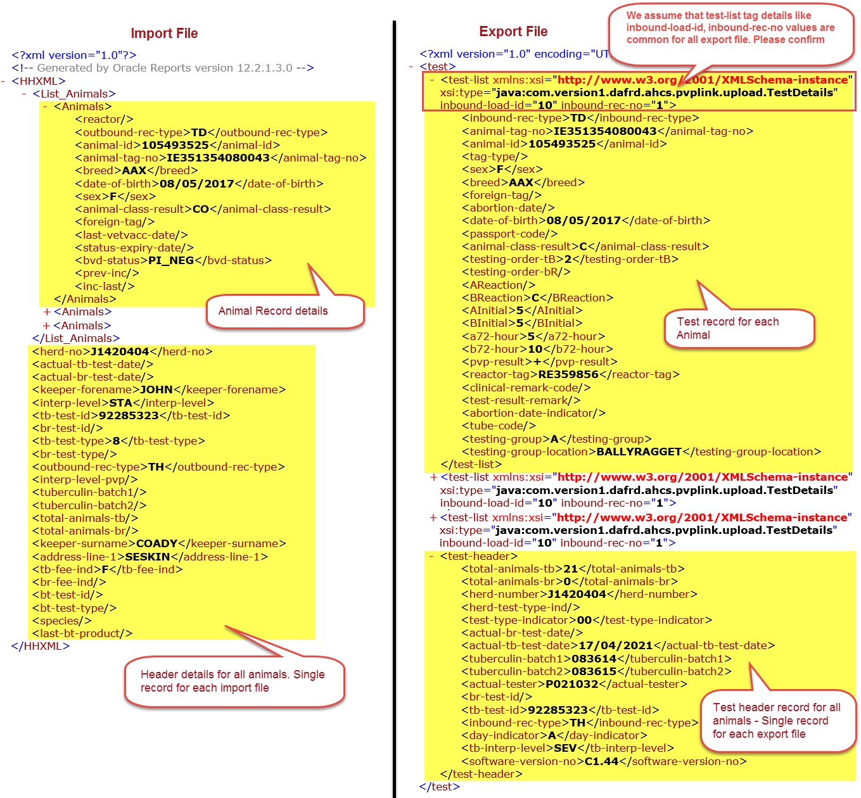

Export File – Test record for each animal

|  |  |  |  |
| --- | --- | --- | --- |
| **#** | **Fields** | **Mapping Field**  **from Import File** | **Comments** |
| 1 | inbound-rec-type |  | Manual entry free text field. We can see the value “TD” for this field |
| 2 | animal-tag-no | animal-tag-no | We can map this field from the import file |
| 3 | animal-id | animal-id | We can map this field from the import file |
| 4 | tag-type |  | Manual entry free text field. We can see the value “TT” for this field for some records only. |
| 5 | sex | sex | We can map this field from the import file |
| 6 | breed | breed | We can map this field from the import file |
| 7 | foreign-tag | foreign-tag | We can map this field from the import file |
| 8 | abortion-date |  | Manual entry date field |
| 9 | date-of-birth | date-of-birth | We can map this field from the import file |
| 10 | passport-code |  | We will add this field as a drop down and the possible values will be NC=No Card, WC=Wrong Card, FC=Full Card, OK=Have Card |
| 11 | animal-class-result | animal-class-result | We can map this field from the import file |
| 12 | testing-order-tB |  | Record the sequence of the animals tested on day 1 for TB test |
| 13 | testing-order-bR |  | Record the sequence of the animals tested on day 1 for Blood test |
| 14 | AReaction |  | We will add this field as a drop down and possible values are   * C (Circumscribed) * D0 (Diffuse Oedema) * E0 (Extensive Oedema)   Even if the readings do not identify the animal as a reactor, the Vet can choose from some override options as above |
| 15 | BReaction |  | We will add this field as a drop down and possible values are   * C (Circumscribed) * D0 (Diffuse Oedema) * E0 (Extensive Oedema)   Even if the readings do not identify the animal as a reactor, the Vet can choose from some override options as above |
| 16 | AInitial |  | Day 1 TB test value for A |
| 17 | BInitial |  | Day 1 TB test value for B |
| 18 | a72-hour |  | Day 2 TB test value for A |
| 19 | b72-hour |  | Day 2 TB test value for B |
| 20 | pvp-result |  | The value will be calculated based on the Standard or Severe measurement. The possible values will be  Positive (+), Negative (-) and Inconclusive (0) |
| 21 | reactor-tag |  | If pvp-result is positive, then the Vet will enter “Reactor TAG number” |
| 22 | clinical-remark-code |  | It will be a manual selection drop down value field.  The possible values are CO=Cough, SN=Snoring, ST=Skin TB, EM=Emaciation, GL=Enlarged Lymph, MA=Mastitis |
| 23 | test-result-remark |  | This field is a free text manual entry field |
| 24 | abortion-date-indicator |  | It will be a manual entry date field |
| 25 | tube-code |  | Manual free text entry field to record Blood bottle number |
| 26 | testing-group |  | Record group like A,B,C |
| 27 | testing-group-location |  | Record location like BALLYRAGGET |

Export File – Test header record for all animals. One record for each export file

|  |  |  |  |
| --- | --- | --- | --- |
| **#** | **Fields** | **Mapping Field**  **from Import File** | **Comments** |
| 1 | total-animals-tb |  | Auto calculated number field.  Total number of animals tested for TB test |
| 2 | total-animals-br |  | Auto calculated number field.  Total number of animals tested for Blood test |
| 3 | herd-number | herd-no | We can map this from the import file |
| 4 | herd-test-type-ind |  | Manual free text entry field |
| 5 | test-type-indicator |  | Manual free text entry field |
| 6 | actual-br-test-date |  | Default to the current date but allow manual override |
| 7 | actual-tb-test-date |  | Default to the current date but allow manual override |
| 8 | tuberculin-batch1 | tuberculin-batch1 | We can map this field from the import file. The user can change the value |
| 9 | tuberculin-batch2 | tuberculin-batch2 | We can map this field from the import file. The user can change the value |
| 10 | actual-tester |  | Manual free text entry field |
| 11 | br-test-id |  | Manual free text entry field |
| 12 | tb-test-id |  | Manual free text entry field |
| 13 | inbound-rec-type |  | Manual free text entry field |
| 14 | day-indicator |  | Manual free text entry field |
| 15 | tb-interp-level |  | Possible values are SEV (Standard) or STA (Severe) |
| 16 | software-version-no |  | Can we use our TKv2 build version to this field? Please confirm |

Clarification

1. We will be using keypad buttons functions in the device
   1. Correct
2. At very first time, the sync is required to download users and animal module structure. The sync will work only in the online mode
   1. Correct
3. When a XML file is imported, will it clear previous data or we need to retain the old animal records.
   1. Multiple files can exist on the handheld for different farmers at the same time.
   2. When 2nd day test is completed and upload done, retain record on handheld for 7 days.
   3. Handheld should default to showing pending tests and not show completed tests
   4. Provide a separate list for completed tests

OK

The completed test list will be completed in Phase 3

1. If two import file has same animal id then will it replace the existing animal data or will it created new animal record in the device when imported. If it will create new animal record with same animal id then we have to add another one steps to select the filename before perform a test. Since more than one file may have same animal id.
   1. A file is a full herd file and the same animal will not be in another file

OK

1. if two animals are in "Reactor" during the test and the app will provide an option to move from standard measurement to severe measurement. Is this mandatory to move from the Standard to Severe measurement for all the animal or optional.
   1. Yes, all change to the same interpretation but the vet has to agree to the change in interpretation does not happen automatically

OK

1. If two animals result will be positive, we will reapply all the animals to severe measurement value as per the documentation. The test result will be override to all the animals.
   1. Correct
2. We assume that only one measurement standard or severe will be applied to all the animal. The combination of both measurement will not be applied for animals. For example, one animal has standard measurement and another one animal has severe measurement. It is not possible since the measurement is available in the test-header section (tb-interp-level STA) and not for individual animal.
   1. One interpretation for all manuals

OK. One interpretation for all animals

1. We need more details about invoicing/prescriptions and ICBG integration to provide a timeline